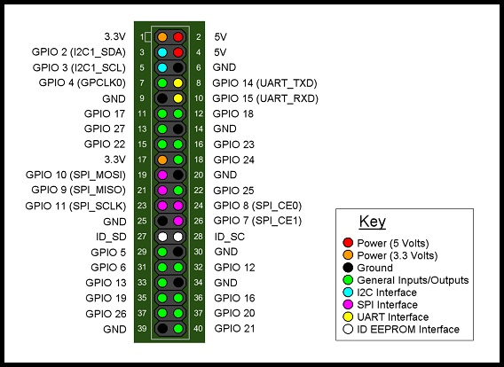

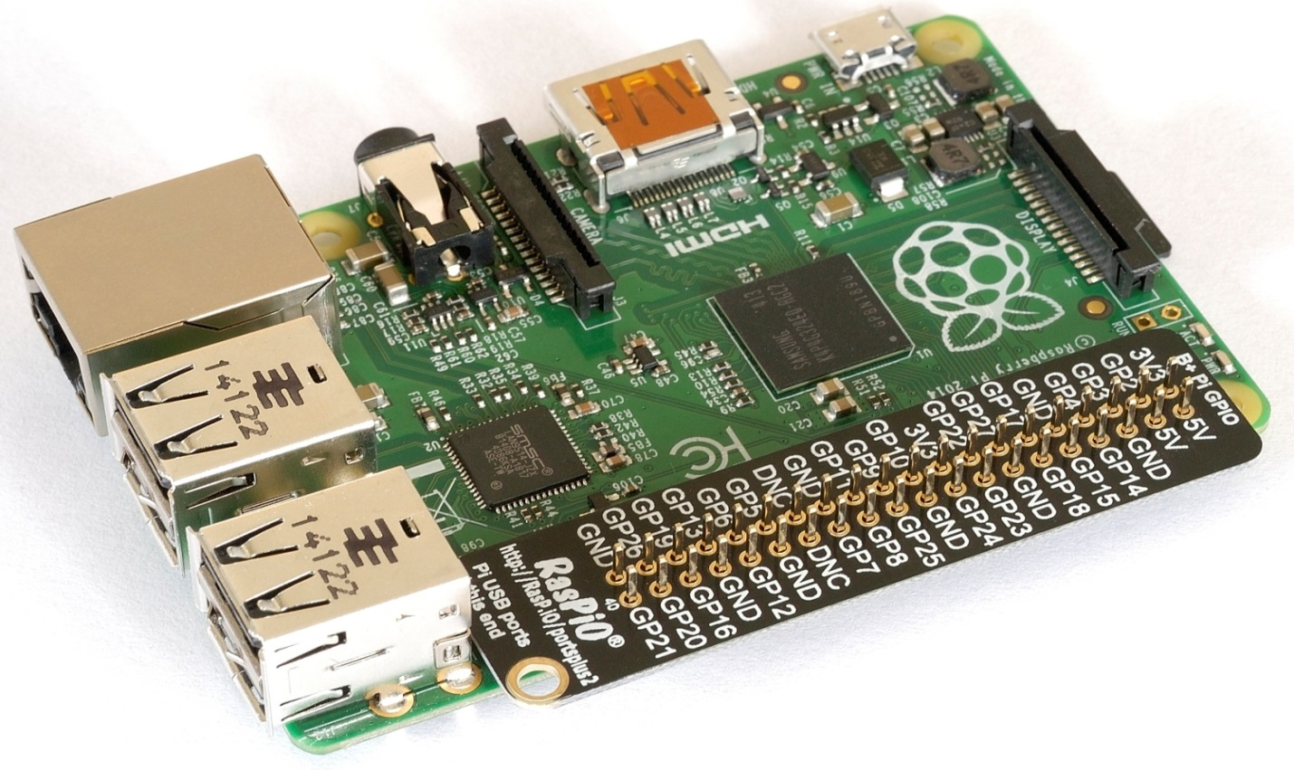

Raspberry Pi B+,2 model header

Sources: Internet

Prepared by: My-Linh Lam Weatherford